Government General Degree College, Mangalkote
Department of English
Date: 01.02.2023
Notice

All concerned are hereby notified that the syllabi of the forthcoming academic sessions are distributed hereunder.

SYLLABUS DISTRIBUTION FOR B.A. ENGLISH (HONS) Semester II: 2023
Course Code / Course Title | Teacher | Topics /Units
(CC III) Indian Writing in English |  | INDIAN ENGLISH POETRY
(CC IV) British Poetry, Drama (16TH – 17TH Centuries) & Rhetoric and Prosody |  | BRITISH POETRY AND MACBETH

TT: TAHIRA TASHNEEM

SYLLABUS DISTRIBUTION FOR B.A. ENGLISH (HONS) Semester IV, 2023
Course Code /Course Title | Teachers | Topics /Units
(CC VIII) British Literature (18th Century) |  | SECTION –A
(CC IX) British Romantic Literature |  | SECTION –A
(CC X ) British Literature (19th Century) |  | POETRY

TT: TAHIRA TASHNEEM

SYLLABUS DISTRIBUTION FOR B.A. ENGLISH (HONS) Semester VI, 2023
Course Code /Course Title | Teacher | Topics /Units
CC XIII (Modern European Drama) |  | HENRIK IBSEN- A DOLL’S HOUSE
CC – XIV Postcolonial Literatures |  | POETRY
DSE –3 (Literary Theory) |  | 1.FEMINISM  2.POSTCOLONIAL STUDIES
DSE -4 (Literary Criticism and History of The English Language) |  | SECTION- B and C

TT: TAHIRA TASHNEEM

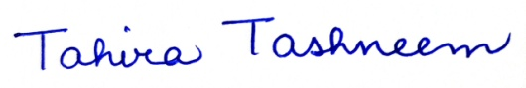
HEAD
DEPARTMENT OF ENGLISH

