GOVERNMENT GENERAL DEGREE COLLEGE MANGALKOTE
DEPARTMENT OF POLITICAL SCIENCE
Distribution of Honours Syllabus

SEMESTER I
PAPERS | MADHUMITA CHAKRABORTY | SK SAHAFUR HOQUE | TINAT RUKSHANA
CC 1 | Ancient  Greek political thought  Medieval  political thought | Renaissance and Machiavelli  Hobbes,  Locke and Rousseau  Marx, Engles and Lenin | Hegel  J. S Mill  and Isaiah Berlin
CC 2 | Marxist  approach, Variants of ideology and end of ideology debate. | Meaning and importance of political theory, decline and resurgence  Rawl’s theory of justice  Theories of state | The  concept of sovereignty,  Liberty and equality,  Traditional,  behavioural and post- behavioural approach

SEMESTER II

PAPERS | MADHUMITA CHAKRABORTY | SK SAHAFUR HOQUE | TINAT RUKSHANA
CC 3 | Ancient  Indian political thought, Kautilya,  Medieval Indian  political thought, Ram Mohan Roy | Gandhi,  Bankimchandra, Vivekananda | Rabindranath Tagore  B. R Ambedkar
CC 4 | Nature of Indian Federalism,Centre- state relations,  Judiciary | The constituent assembly,  preamble  Union legislature  Fundamental rights, duties and directive  principles | Union executive  Party system  Electoral process

SEMESTER III

PAPERS | MADHUMITA CHAKRABORTY | SK SAHAFUR HOQUE | TINAT RUKSHANA
CC 5 | Transition from comparative govt to politics, nature and  scope  Legislatures in UK, USA | Conventions  and rule of  law in UK, bill of rights  Unitary and  federal system | Parliamentary and presidential system  Party system in UK, USA and France + Judiciary in UK
CC 6 | Neo-classical theories  Major approaches in Public Administration | Meaning,  significance, evolution of public administration  Classical  theories | Contemporary theories  Concepts of administration
CC 7 | 73rd amendment act  74th amendment act | Rural  administration, urban administration  District  administration | State administration  Administrative reforms
SEC 1 | Budget | Powers and  functions of people’s representative,  Supporting  the legislative process | Examination of demands for grants

SEMESTER IV
PAPERS | MADHUMITA CHAKRABORTY | SK SAHAFUR HOQUE | TINAT RUKSHANA
CC 8 | Balance of power,  Post-cold war global issues, Indian foreign policy | Origin and  end of cold war,  Disarmament | Nature and  scope of IR  National  power + foreign policy and diplomacy
CC 9 | Feminism,  Environment and politics, State and civil society | Political  sociology and sociology of politics,  Political  culture and socialization + political participation | Concepts of  power and authority,  Religion and  politics
CC 10 | UNITED NATIONS,  Regional economic organizations | Regional  security organizations,  Regional  organizations | Evolution of  international organizations,  Peacekeeping  and peace- building role of the UN
SEC 2 | Laws relating to dowry etc. | Constitution, Lok adalats | Anti-  terrorist laws,  System of courts

SEMESTER V
PAPERS | MADHUMITA CHAKRABORTY | SK SAHAFUR HOQUE | TINAT RUKSHANA
CC 11 | Trade  union movement  Women’s movement | Social movements  Environmental movements | Dalit movement  Peasant movements
CC 12 | Methodology  Vocabulary of research | Meaning and objective of social science  research | Components of research design  Methods and techniques of data collection
DSE 1 | Features of Indian and western thought  Kautilya + Aristotle | Tilak and Gandhi  Rousseau + Nehru and JP Narayan | Ambedkar + Locke  J. S Mill
DSE 2 | Global economy  Global poverty | Dynamics of civil society | Evolution of state system  Transnational economic actors

SEMESTER VI

PAPERS | MADHUMITA CHAKRABORTY | SK SAHAFUR HOQUE | TINAT RUKSHANA
CC 13 | Key determinants of India's Foreign Policy, India's Foreign Policy towards her neighbours | India and the major powers | Recent trends in India's Foreign Policy
CC 14 | Women, Political Economy of Poverty and Inequality, Disaster Risk Reduction and Development Planning | Secularism and Communalism, Caste system in India | Rights of persons with disabilities in India, Social backwardness and protective discrimination
DSE 3 | Evolution of Rural and Urban local governments in West Bengal | Structure and functions of Panchayati Raj in West Bengal, Structure and functions of Municipality in West Bengal | Local government and empowerment of women, SCs and STs, Financial control of the state
DSE 4 | Major approaches to the study of Political Economy, evolution of global trade regime | WTO and developing countries, trends in global trade and finance | From GATT to WTO, WTO

- PLEASE REFER TO THE SYLLABUS FOR DETAILS. HERE I HAVE ONLY MENTIONED THE BROADER TOPICS.

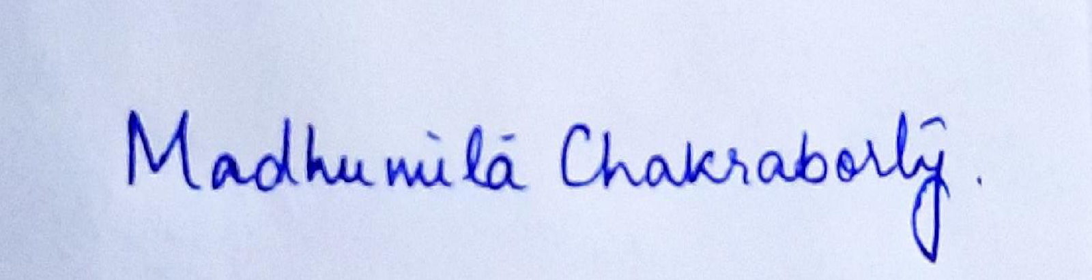
Head, Dept of Political Science

